Notes: API Gateway in Microservices

1. Context & Recap of Existing Architecture
- Previous Setup: The microservices project has three core services, each with its own separate codebase and database:
  - Hotel Service — manages hotel data (runs on port 8082)
  - User Service — manages user data (runs on port 8081)
  - Rating Service — manages ratings (runs on port 8083)
- Flow: A client request goes to the User Service. The User Service then calls the Rating Service (to fetch ratings) and the Hotel Service (to fetch hotel details), combines the results, and returns the response to the client.
- Config Server: A separate Config Server can be used to store common configuration for all services.
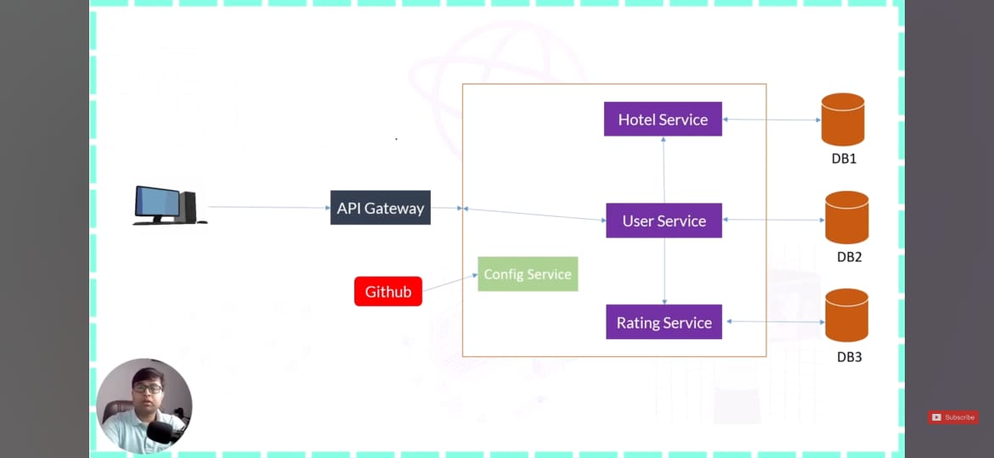

2. The Problem: Clients Must Call Every Service Separately
- Current Reality: In the project so far, the client (e.g., Postman) is calling each microservice directly on its own URL and port:
  - User details → http://127.0.0.1:8081
  - Hotel details → http://127.0.0.1:8082
  - Rating details → http://127.0.0.1:8083
- Why this is a problem:
  - Every service runs on a different port because each is a separate project.
  - The client must know every URL and port to communicate with the system.
  - In a real application with 50+ microservices, the client would need to manage 50+ URLs — impractical and unmaintainable.
  - If a service's port or URL changes (e.g., from 8083 to 8084), the client must be updated — creating unwanted dependencies.
- Analogy (Wedding Example):
  - If you have 1,000 guests at a wedding, you cannot personally tell each guest "come eat" 1,000 times.
  - Instead, you tell one common person, and that person relays the message to everyone.
  - Similarly, the client should talk to one common entry point — not every service individually.
- Analogy (Door/Gate Example):
  - You don't need to find different doors for different destinations. You have one gate — you enter through it, and the gate handles the directions.
  - The client enters through the API Gateway, and the gateway routes the request to the correct service.

3. The Solution: API Gateway
- What it is: A single entry point for the entire application. The client calls only the API Gateway, and the gateway forwards the request to the appropriate microservice.
- How it works:
  - Client calls: http://<gateway-host>:<gateway-port>/...
  - The API Gateway inspects the request and routes it to the correct service (User Service, Hotel Service, or Rating Service).
  - The client no longer needs to know individual service URLs or ports.
- Configuration: The API Gateway holds routing configuration — it knows which service is registered and where to forward each request.

4. Benefits of API Gateway
- Single URL for the Client: The client uses only one URL (the gateway's URL) instead of managing many URLs/ports.
- Decoupling: If a service's port or URL changes, only the gateway configuration needs updating — the client is unaffected.
- Simplified Client: The client doesn't need to know the internal architecture of the microservices.
- Centralized Routing: All routing logic lives in one place, making the system easier to maintain and evolve.

5. Key Point: API Gateway is Itself a Microservice
- The API Gateway is not a special, separate technology — it is itself a microservice (a Spring Boot project).
- Just like the Config Server and Service Registry (Eureka) are their own microservices, the API Gateway is a separate Spring Boot project with its own code and configuration.
- Do not think of the API Gateway as something "outside" the microservices architecture — it is a component within it.
- All components built in this series (Eureka Server, API Gateway, Config Server, Hotel Service, User Service, Rating Service) are all microservices.

6. Practical Setup Demonstrated in the Video
- All services were running simultaneously:
  - User Service → port 8081
  - Hotel Service → port 8082
  - Rating Service → port 8083 (was temporarily on 9093, then changed back to 8083)
- Without API Gateway: Postman was calling each service on its own URL/port directly.
- With API Gateway: The client will call the gateway, which forwards to the appropriate service.
- Note: 127.0.0.1 and localhost are the same — both refer to the local machine. Either can be used.

7. Summary
Aspect | Without API Gateway | With API Gateway
Client calls | Every service separately (different URLs/ports) | Only the API Gateway
URL management | Client must know all service URLs | Client knows only one URL
Service port changes | Client must be updated | Only gateway config changes
Scalability | Impractical with many services | Clean and maintainable
Entry point | Many entry points | Single entry point

8. Key Takeaways
- API Gateway solves the "multiple URL" problem in microservices — clients communicate with one entry point.
- The gateway forwards requests to the correct service based on its configuration.
- The API Gateway is itself a microservice — a separate Spring Boot project.
- Changes to internal services (ports, URLs) are isolated from the client because the gateway handles routing.
- The next video in the series will demonstrate practical implementation of the API Gateway in the project.

